**Task7 Java web聊天室应用构建**

1. **聊天室的主要部分**
2. **登录与注册。**
3. **聊天框的设计。**
4. **聊天室的实现**
5. **登录与注册**

**基于html的登录注册代码：**

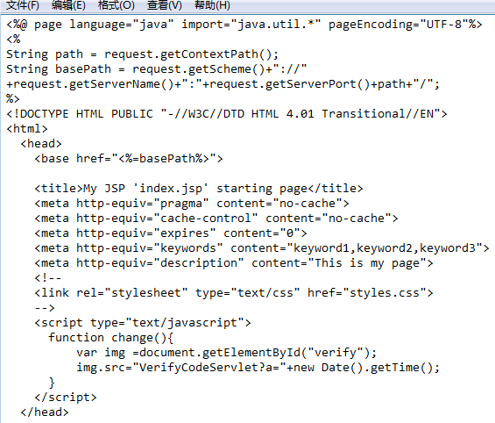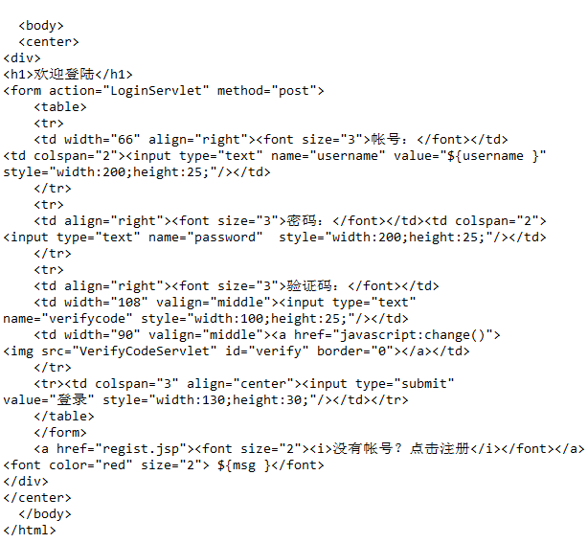

**登录界面：**

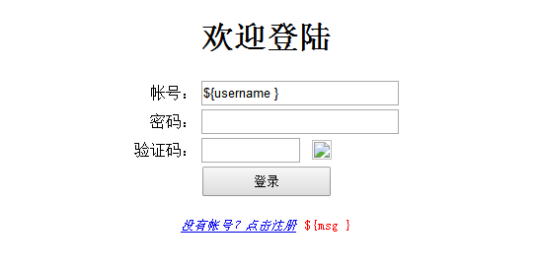

**注册主要代码：**

**public class sign {**

**public static void main(String[] args) throws IOException{**

**File xx=new File("D:/信息.txt");**

**final BufferedWriter bws=new BufferedWriter(new OutputStreamWriter(new FileOutputStream(xx)));**

**BufferedReader brs=new BufferedReader(new InputStreamReader(new FileInputStream(xx)));**

**Frame fr=new Frame("seven");**

**Label be1=new Label("姓名：",Label.CENTER);**

**Label be2=new Label("密码：",Label.CENTER);**

**Label be3=new Label("确认密码：",Label.CENTER);**

**final TextField[] tf=new TextField[]{**

**new TextField(20),new TextField(20),new TextField(20)};**

**// final TextField tf2=new TextField(20);**

**// final TextField tf3=new TextField(20);**

**Button btok=new Button("注册");**

**Button btce=new Button("取消");**

**btok.addActionListener(new ActionListener(){**

**public void actionPerformed(ActionEvent e){.....}}**

1. **聊天框设计**

**主要代码：**

**public class UDPchat extends JFrame implements ActionListener{**

**public TextArea textmessage = null;**

**public TextArea sendtext = null;**

**public DatagramSocket socket;**

**public JScrollBar vsBar;**

**public UDPchat()**

**{**

**super();**

**setTitle("小型聊天程序");**

**setBounds(200,150,350,280);**

**JPanel panel1 = new JPanel();**

**JPanel panel2 = new JPanel();**

**setDefaultCloseOperation(JFrame.EXIT_ON_CLOSE);**

**setBackground(Color.BLUE);**

**textmessage = new TextArea();**

**sendtext = new TextArea();**

**textmessage.setEditable(false);**

**textmessage.setColumns(35);**

**textmessage.setRows(10);**

**// textmessage.setLineWrap(true);**

**sendtext.setColumns(35);**

**sendtext.setRows(2);**

**JButton buttonOK = new JButton("确定");**

**JButton buttonclean = new JButton("清空");**

**JButton buttonquit = new JButton("退出");**

**JButton buttonclicent = new JButton("用户列表");**

**JButton buttonone = new JButton("私聊");**

**JButton buttonmuch = new JButton("群聊");**

**JButton buttonaddfriend = new JButton("添加好友");**

**JButton buttonremovefriend = new JButton("删除好友");**

**GridLayout grid = new GridLayout(8,1);**

**grid.setHgap(10);**

**grid.setVgap(10);**

**panel1.setLayout(grid);**

**// panel1.setLayout(new GridLayout(3,1));**

**panel1.add(buttonOK);**

**panel1.add(buttonclean);**

**panel1.add(buttonquit);**

**panel1.add(buttonclicent);**

**panel1.add(buttonone);**

**panel1.add(buttonmuch);**

**panel1.add(buttonaddfriend);**

**panel1.add(buttonremovefriend);**

**panel2.setLayout(new FlowLayout());**

**panel2.add(textmessage);**

**panel2.add(sendtext);**

**panel2.add(buttonclicent);**

**getContentPane().add(panel1,BorderLayout.EAST);**

**getContentPane().add(panel2,BorderLayout.CENTER);**

**setVisible(true);**

**buttonOK.addActionListener(this);**

**buttonclean.addActionListener(this);**

**buttonquit.addActionListener(this);**

**buttonclicent.addActionListener(this);**

**server();**

**}**

**public void server()**

**{ ..... }**

**为按钮添加相关的事件监听即完成了聊天室的基本构建。**

**事件监听的代码实现**

**例如：public void actionPerformed(ActionEvent e) {**

**// JButton button = (JButton) e.getSource();**

**String buttonname =e.getActionCommand();**

**if(buttonname.equals("退出"))**

**System.*exit*(0);**

**if(buttonname.equals("清空"))**

**{**

**textmessage.setText("");**

**}**

**if(buttonname.equals("确定"))**

**{**

**String iP = "192.168.8.15";**

**try {**

**InetAddress address =InetAddress.*getByName*(iP);**

**byte []data = sendtext.getText().getBytes();**

**DatagramPacket dp = new DatagramPacket(data,data.length,address,9527);**

**String myip = InetAddress.*getLocalHost*().getHostAddress();**

**textmessage.append(myip +" \n"+sendtext.getText() +"\n");**

**socket.send(dp);**

**sendtext.setText("");**

**} catch (UnknownHostException e1) {**

**// TODO Auto-generated catch block**

**e1.printStackTrace();**

**} catch (IOException e1) {**

**// TODO Auto-generated catch block**

**e1.printStackTrace();**

**}**

**}**

**完成聊天室的构建后，还需要对web聊天室进行各种测试。**